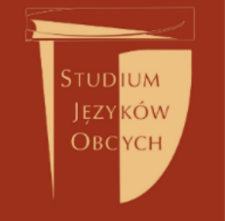

Registration form
The Department of Foreign Languages of Wrocław University of Technology
Teacher Training Course
Wrocław, 09-16 August 2017

Last name:
First name:
Address:
Mobile nr.:
E-mail:

Method of Payment:
- The participant undertakes to make payment in EUR to the account of the University as follows:
Bank Zachodni WBK S.A.
16 Oddział Wrocław
50-373 Wrocław, ul. Norwida 1/3
PL 91 1090 2402 0000 0006 1000 0626
SWIFT WBK PPL PP
With a note: Teacher Training Course, name and surname of the Participant,
Payee’s name: Wroclaw University of Technology
Please provide proof that a third party is to pay the fee for the course. This proof should be enclosed with this registration form as a scan or photo. If this proof is not enclosed, your registration will not be processed.

