NATIONAL TECHNICAL UNIVERSITY OF UKRAINE
«IGOR SIKORSKY KYIV POLYTECHNIC INSTITUTE»

Department of Theory, Practice and Translation of French
Kyiv School of Phonetics
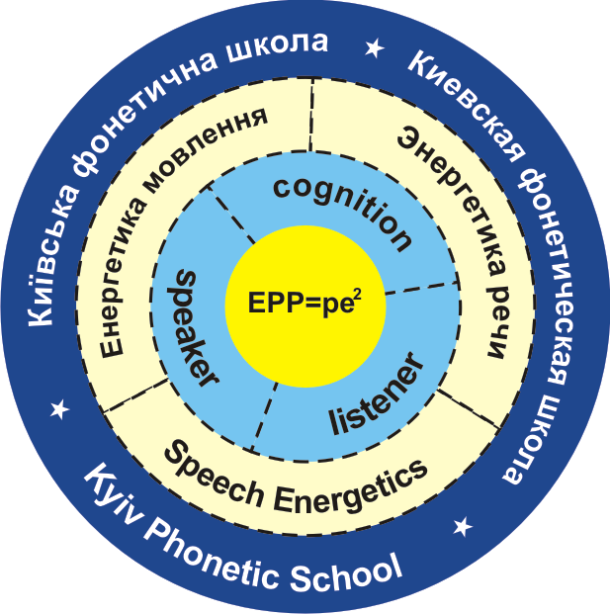

CALL FOR PAPERS
VІ International Round Table
«CURRENT TRENDS IN PHONETIC STUDIES»

Dear colleagues,

We are pleased to invite you to participate in the VI International Round Table Discussion «Current trends in phonetic studies» to be held on April 21, 2023, on the premises of the Faculty of Linguistics of National Technical University of Ukraine “Igor Sikorsky Kyiv Polytechnic Institute”, departments of Theory, Practice and Translation of French and Theory, Practice and Translation of English.

ABSTRACTS ARE WELCOMED IN THE FOLLOWING SECTIONS:
1. Present day studies of the sound structure of language and speech.
2. Communicative, cognitive, energetic, cultural, ecolinguistic and pragmatic aspects of phonetic studies of discourse.
3. Phonosemantic and phonostylistic studies of texts of different genres.
4. Individual’s emotions, feelings and sensations and their prosodic expression in speech.
5. Identification of the speaker’s personality by his/her speech prosodic organization.
6. Constant and variable features of socio-phonetic parameters of speech.
7. Approaches, directions and aspects of studying phonetic universals.
8. Correlation of verbal and non-verbal means in emotional speech.
9. Contrastive studies of phonetic systems of Ukrainian and other foreign languages.
10. Current trends in methodology of teaching phonetics.

Languages of the conference: Ukrainian, English, German, French.
Materials of the Round Table Discussion will be published before the conference in the e-book of conference proceedings and on the conference’s website.
To participate, please, submit the following documents via e-mail: ktppamm@gmail.com
1. Registration form (see the form below).
2. Abstracts formatted in accordance with the requirements (see below). Abstracts must not exceed 4 pages.
Deadline for papers submission is March 26, 2023.

Organizing Committee
Department of Theory, Practice and Translation of French
Department of Theory, Practice and Translation of English
Tel: (044) 204 83 58

Conference Coordinator
Doctor of Philological Sciences, professor – Larysa Taranenko
Cell: (+38) 050 353 52 34.

Requirements for formatting abstracts
- Language: Ukrainian, English, French, German.
- The text should be formatted using Microsoft Office Word (*doc), 14-point type, Times New Roman font. Page size is A4; all margins (top, bottom, right and left) are 2 cm. Line spacing is 1.
- The first line: title of the paper (center alignment, capital letters, bold type, 14-point, Times New Roman font).
- The second line: the surname and initials of the author (center alignment, bold and italic type, 14-point, Times New Roman font).
- The next line: affiliation (center alignment, italic type, 14-point, Times New Roman font).
- The next line: email of the author(s) (center alignment, italic type, 14-point, Times New Roman font).
- A brief summary (up to 5 sentences) and key words (5-7 words) are placed after the one-line interval (italic type, 12-point, Times New Roman font).
- The text of the abstract is placed after the one-line interval (14-point type, Times New Roman font).
- The sources (under the heading References) should be provided at the end after one-line interval in the alphabetical order (14-point type, Times New Roman font) according to APA Style format.
- Citations in the text are provided in APA Style format.
In case an abstract contains schemes, diagrams, figures or formulas they must be represented as text element and fixed in an appropriate place.
Schemes, figures and formulas are also attached in separate files (*jpg or *bmp)
Special fonts are attached in a separate archive.

Formatting sample:

PROSODIC MEANS OF ENGLISH FOLKLORE TEXTS ACTUALIZATION
Larysa Taranenko
National Technical University of Ukraine «Igor Sikorsky Kyiv Polytechnic Institute»
litera@i.ua

Summary (in English)

Text

References

Registration Form
Round Table Discussion
«Current Trends in Phonetic Studies»
Kyiv, April 21, 2023

First Name, Last Name
University Affiliation
Scientific Degree, title

Position
E-mail
Cell phone number
Title of presentation

Section
Form of participation (Absentee participation with the abstracts publication) / Personal Participation

